Experiment: 1.2

**Aim:**

Write a program to implement Data Visualization and Exploration using Tableau

**Software Required:**

IDE used is Tableau

**Description:**

In this experiment, the goal is to develop a program that utilizes Tableau, a powerful data visualization and exploration tool, to create interactive visualizations and analyze data. The program will be designed to facilitate the process of extracting insights and patterns from complex datasets by providing an intuitive graphical interface.

The program will leverage Tableau's features and functionality to accomplish various tasks related to data visualization and exploration. Some of the key aspects that the program will cover include:

* + **Data Import and Connection**: The program will enable users to import data from different sources such as spreadsheets, databases, or web services. It will establish a connection with the data source and retrieve the required datasets for visualization and analysis.
  + **Data Preparation and Transformation**: The program will provide options to preprocess and transform the data to ensure its suitability for visualization. This may involve cleaning up data, handling missing values, aggregating data, or performing calculations.
  + **Visualization Creation**: Using Tableau's capabilities, the program will allow users to design and generate a variety of visualizations such as charts, graphs, maps, and dashboards. Users can customize the visual appearance, apply filters, and combine multiple visual elements to create informative and compelling representations of the data.
  + **Interactivity and Exploration**: The program will enable users to interact with the visualizations dynamically. They can explore the data by zooming, panning, and filtering to gain deeper insights. Users can also define interactive elements such as tooltips, drill-downs, or parameter controls to enhance the exploration experience.
  + **Analysis and Insights:** The program will support data analysis by providing statistical calculations, trend analysis, and other analytical features. Users can perform aggregations, create calculated fields, and generate summary statistics to uncover patterns, correlations, or outliers within the data.
  + **Sharing and Collaboration**: The program will facilitate sharing visualizations and insights with others. Users can save their work in different formats, publish dashboards online, or export visualizations for further use in reports or presentations. Collaborative features such as annotations, commenting, and version control may also be incorporated.

**Pseudo code/Algorithms/Flowchart/Steps:**

1.**Introduction to Tableau:**

Provide an overview of Tableau and its significance in data visualization and business intelligence.

Explain the key features and functionalities of Tableau that enable effective data exploration and visualization.

2.**Dataset Selection and Understanding:**

Select a suitable dataset for visualization and exploration.

Familiarize yourself with the dataset's structure, variables, and any relevant domain-specific information. Perform necessary data preprocessing steps, such as cleaning, filtering, or transforming the data, if required.

3.**Connecting Data to Tableau:**

Launch Tableau Desktop and connect to the chosen dataset.

Choose the appropriate data source and configure the connection settings.

Verify the successful connection and preview the data within Tableau.

4.**Basic Visualization Techniques:**

Create basic visualizations in Tableau, such as bar charts, line charts, scatter plots, or pie charts. Customize the visualizations by modifying colors, labels, titles, and other properties.

Apply suitable aggregation functions or filters to visualize specific aspects of the data.

**5.Advanced Visualization Techniques:**

Explore advanced visualization techniques in Tableau, such as treemaps, heatmaps, area charts, or geographic maps.

Utilize Tableau's features for drill-down, hierarchy, or grouping to analyze the data at different levels of granularity.

Implement interactive elements, such as filters, parameters, or actions, to enhance user interactivity and exploration.

6.**Dashboard Creation: Combine multiple visualizations into a cohesive dashboard in Tableau**.

Arrange the visualizations logically and aesthetically within the dashboard layout.

Add appropriate titles, annotations, and legends to provide context and clarity to the dashboard.

7.**Dashboard Interactivity and Navigation:**

Enhance the dashboard with interactive features to enable user exploration.

Incorporate filters, quick filters, or drop-down menus to allow users to interactively slice and dice the data.

Implement actions or tooltips to provide additional details or insights when users hover or click on specific elements.

8. **Storytelling with Data: Utilize Tableau's storytelling features to create a compelling narrative with the data.**

Arrange multiple dashboards or visualizations into a coherent data story.

Add annotations, captions, or text objects to guide the audience through the data story and highlight key insights.

**9.Sharing and Collaboration**: Explore different methods for sharing Tableau visualizations and dashboards, such as publishing to Tableau Server, Tableau Public, or exporting as image or PDF files.

Discuss collaboration options in Tableau, including sharing workbooks, collaborating with team members, or embedding visualizations in other applications.

**10.Experimentation and Analysis:** Experiment with different visualization techniques, layouts, or interactions to explore the dataset and derive meaningful insights.

Analyze the visualizations and discuss the patterns, trends, or relationships observed in the data.

Interpret the findings in the context of the dataset's domain and formulate actionable recommendations.

**Output:**

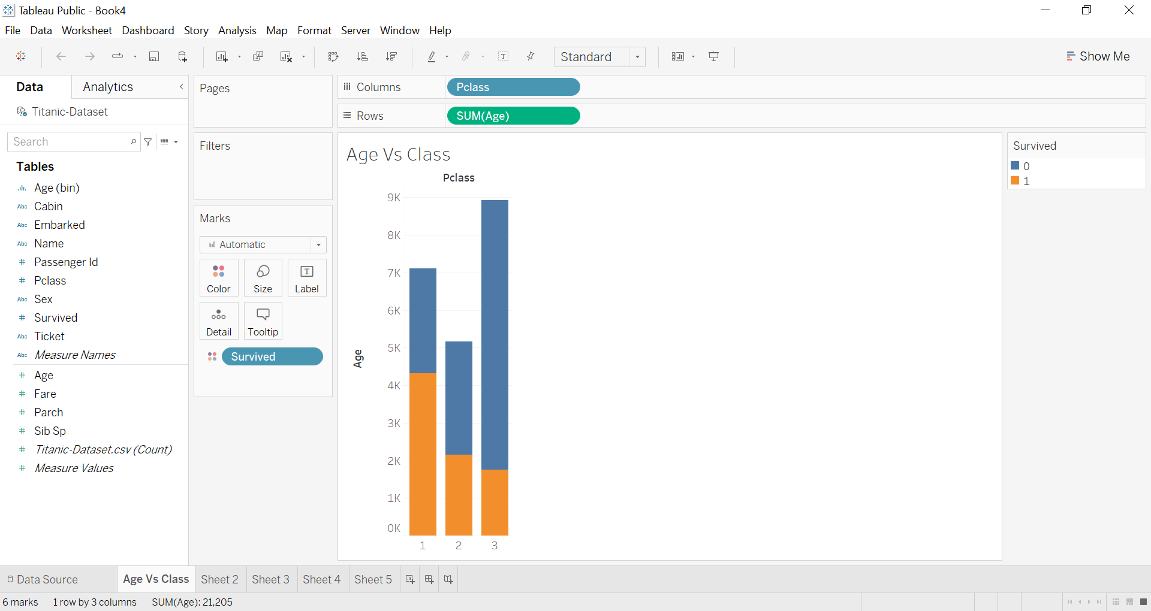

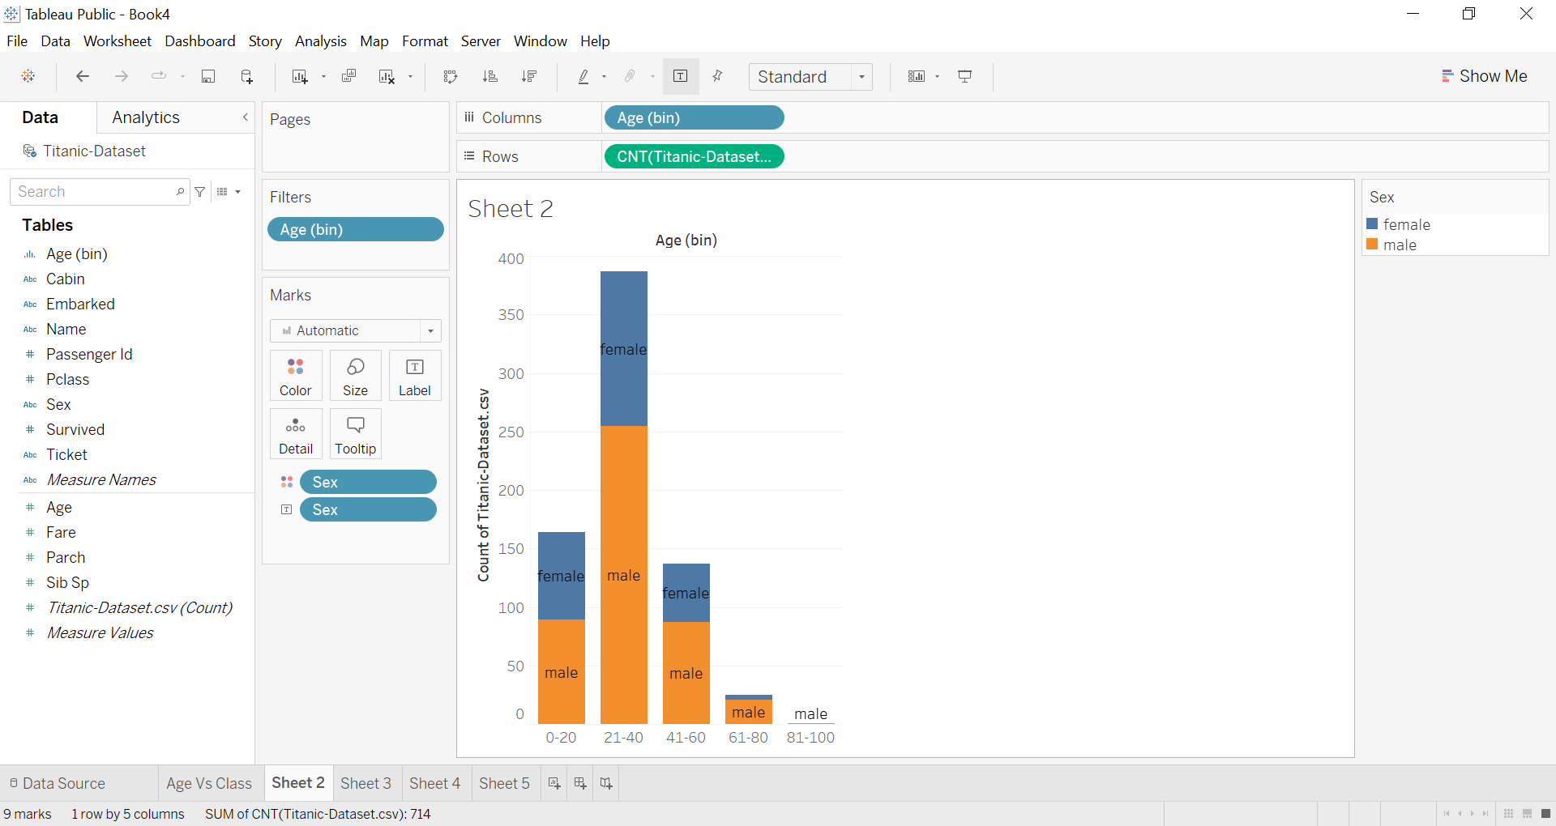

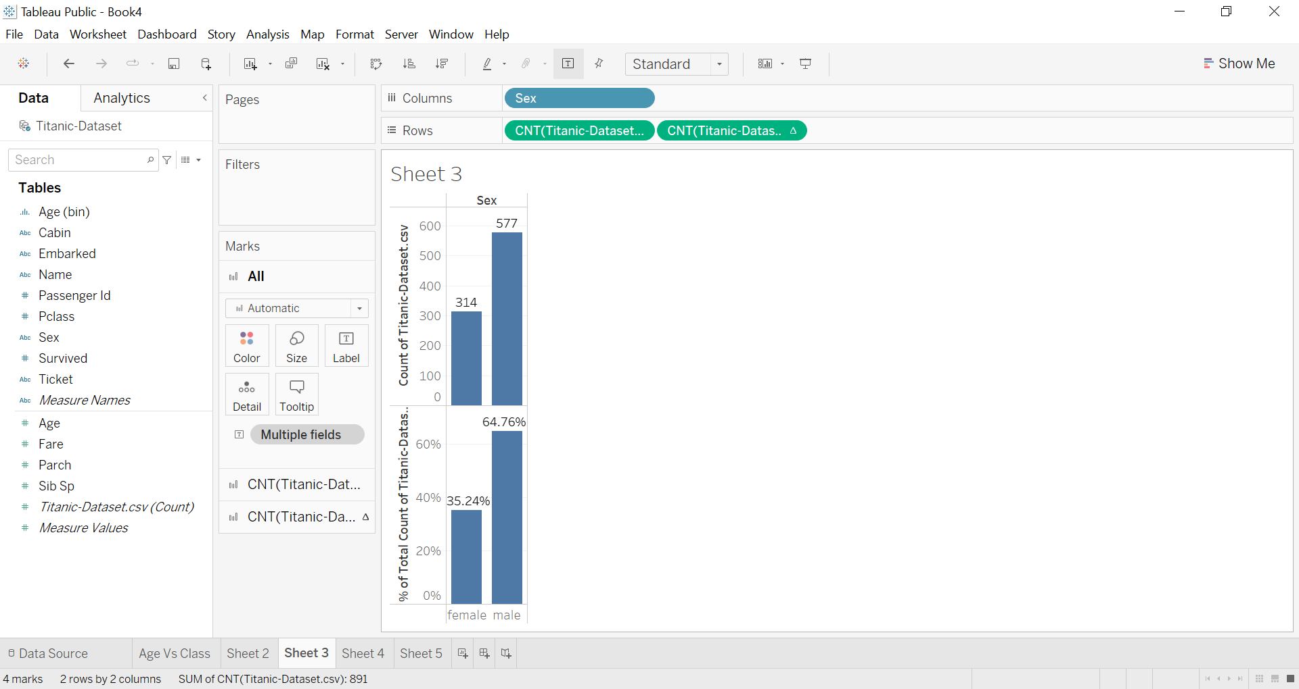

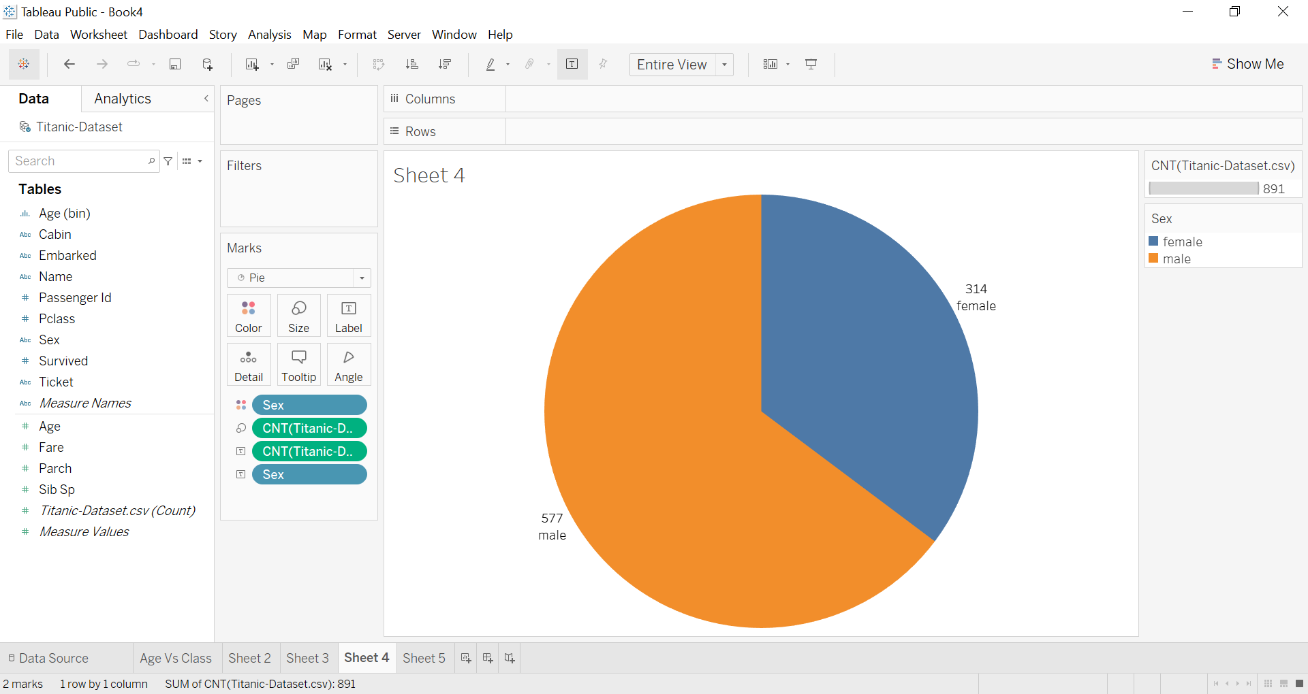

**Learning Outcomes:**

1. Understand the concepts and principles of data visualization.
2. Demonstrate proficiency in using Tableau software for data visualization and exploration.
3. Apply various visualization techniques to effectively communicate data insights.
4. Interpret and analyze data using interactive visualizations created in Tableau.
5. Identify patterns, trends, and outliers in data through visual exploration.